PAR-Q
PHYSICAL ACTIVITY READINESS QUESTIONNAIRE

Regular physical activity is fun and healthy and being more active is very safe for most people. However, some people should check with their doctor before they start becoming much more physically active.
If you are planning to become much more physically active than you are now, start by answering the questions below. If you are between the ages of 15 and 69, the PAR-Q will tell you if you should check with your doctor before you start. If you are over 69 years of age, and you are not used to being very active, check with your doctor.
Common sense is your best guide when you answer these questions. Please read the questions carefully and answer each one honestly: check YES or NO.

YES NO
- Has your doctor ever said that you have a heart condition □ □ and that you should only do physical activity
recommended by a doctor?

- Do you feel pain in your chest when you do physical □ □
activity?

- In the past month, have you had chest pain when you □ □
were not doing physical activity?

- Do you lose your balance because of dizziness or do you □ □
ever lose consciousness?

- Do you have a bone or joint problem (for example, back , □ □
knee, shoulder or hip) that could be made worse by a
change in your physical activity?

- Is your doctor currently prescribing drugs for your blood □ □
pressure or heart condition?

- Have you undergone any operations/ had any illnesses □ □ that may affect you exercising?

- Are you/have you in the last year been pregnant? □ □

- Are you asthmatic? □ □
- Are you currently taking any medications? □ □
- Do you know of any other reason why you should not □ □
do physical activity?

If you answered YES to one or more questions:

Talk with your doctor by phone or in person BEFORE you start becoming much more physically active. Tell your doctor about the PAR-Q and which questions you answered YES.

You may be able to do any activity you want to- as long as you start slowly and build up gradually. Or, you may need to restrict your activities to those that are safe for you. Talk with your doctor about the kinds of activities you wish to participate in and follow his/her advice.

If you answered NO honestly to all PAR-Q questions, you can be reasonably sure that you can:
Start becoming much more physically active-begin slowly and build up gradually. This is the safest and easiest way to go.
It is also recommended that you have your blood pressure evaluated. If your reading is over 144/94, talk with your doctor before you start becoming much more physically active.

Delay becoming much more active:
If you are not feeling well because of a temporary illness such as a cold or a fever-wait until you feel better; or
If you are or may be pregnant – talk to your doctor before you start becoming more active.
Please note: If your health changes so that you then answer YES to any of the above questions, please inform me.

I have read, understood and completed this questionnaire. Any questions I had were answered to my full satisfaction.

Name: _____________________

Signature: _____________________

Date: _____________________
Note: this physical activity clearance is valid for a maximum of 12 months from the date it is completed and becomes invalid if your condition changes so that you would answer YES to any of the questions.

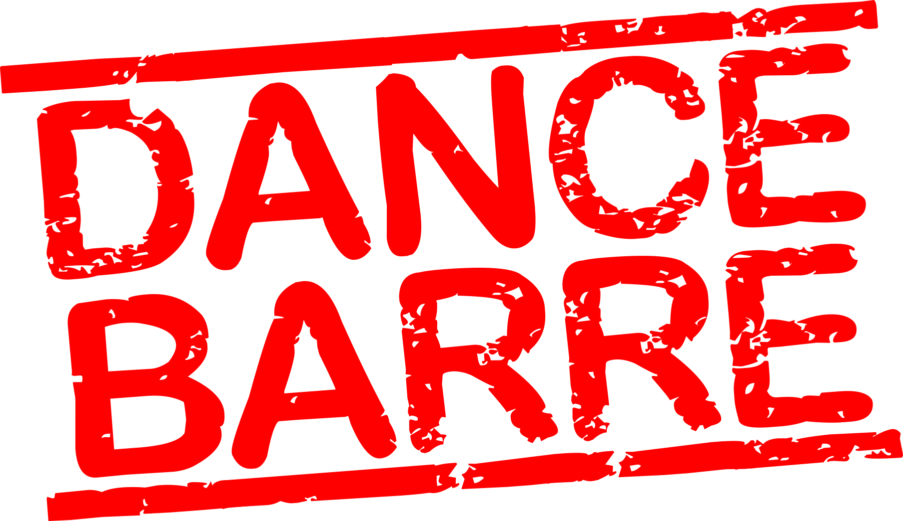 Jo@thedancebarre.co.uk

